Jallipalli, Lakshmi Susmitha Jayasri SBOBNG-PTIY/AAF

Shell india markets private ltd

CASE STUDY

SDLC, AGILE, software testing, ci/cd using github actions

**Website (OrangeHRM):**

<https://opensource-demo.orangehrmlive.com/web/index.php/auth/login>

**SDLC, Agile and Software Testing**

1. Open Azure Devops
2. Create an Azure Virtual Machine (VM)

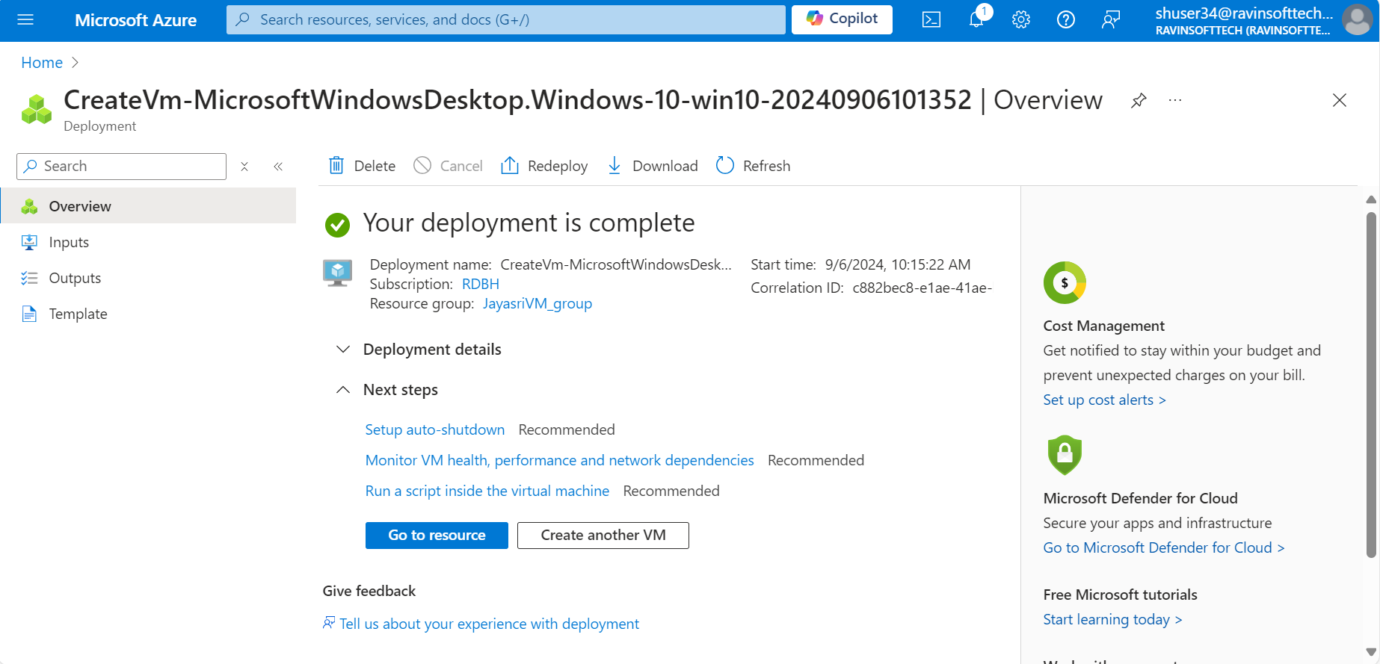

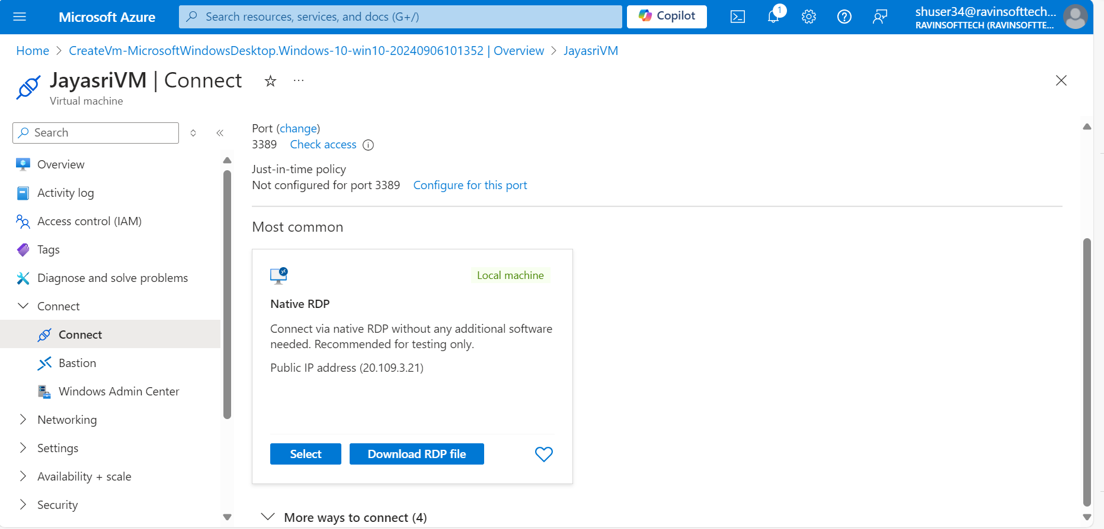

1. Login to the azure devops portal and navigate to the project.
2. Create a New Sprint. Set the Sprint goals and objectives, aligning them with the overall testing strategy for the website.

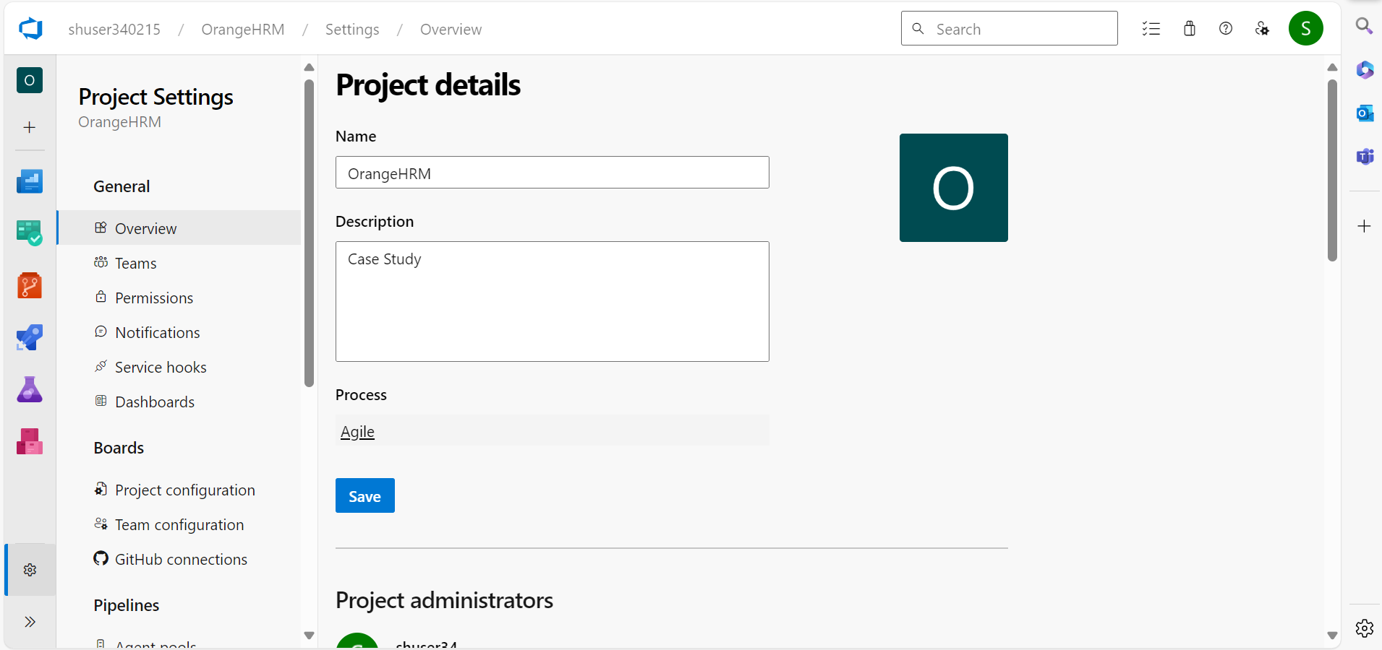

1. Create 5 User Stories in the Sprint for the Sprint Backlog for the given application.
2. Each user story should cover different aspects of the Software Development Life Cycle (SDLC) as it relates to the functionalities of the website.

**EPIC:**

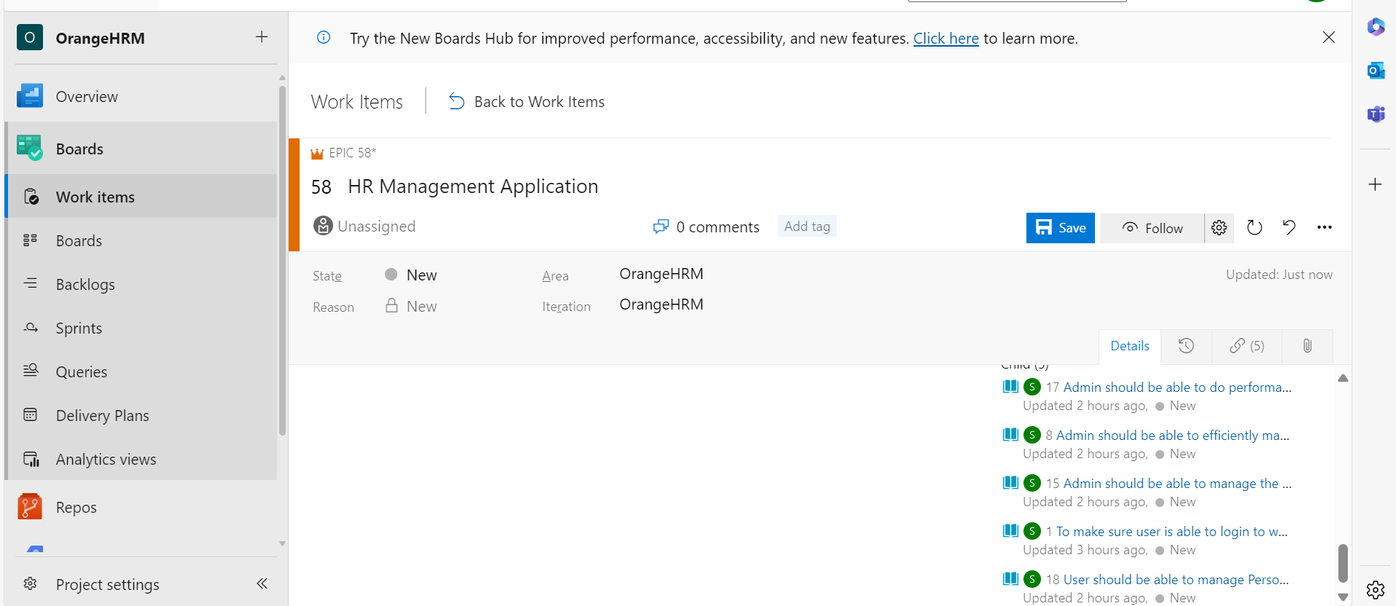

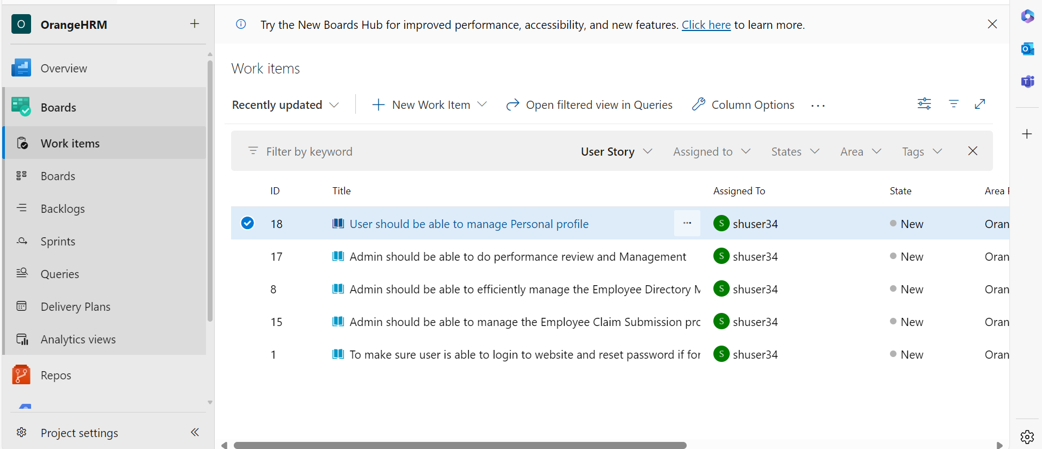

**User Story-1**

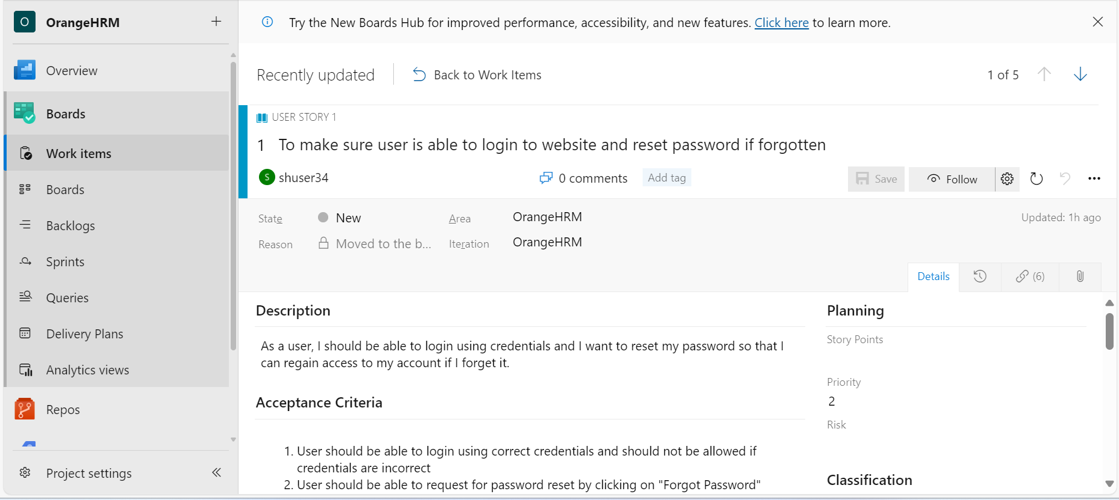

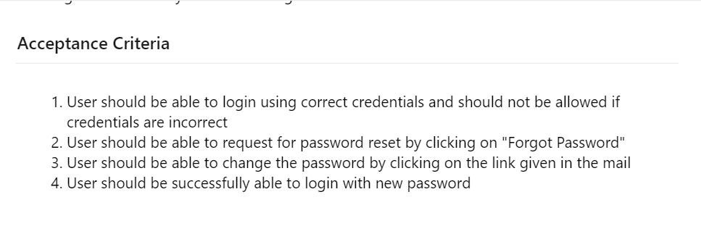

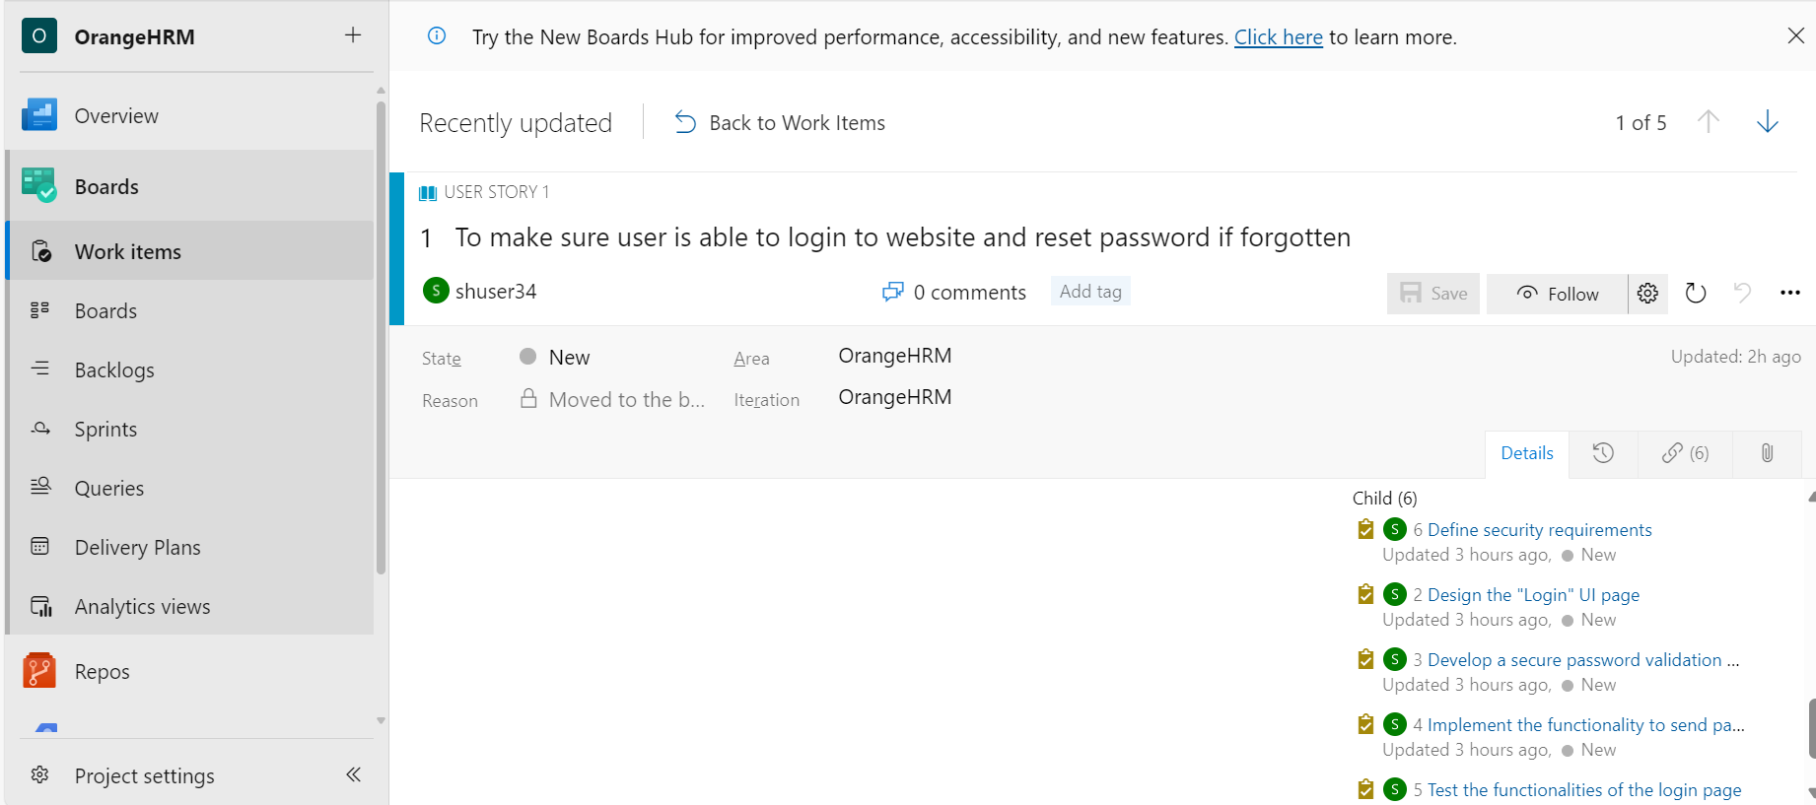

**User Story-2**

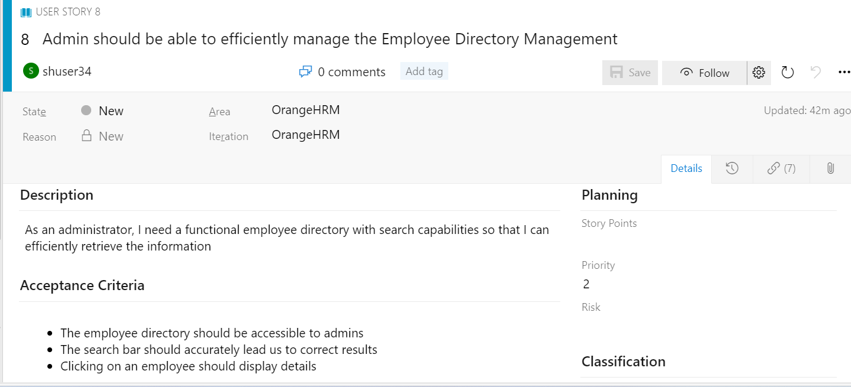

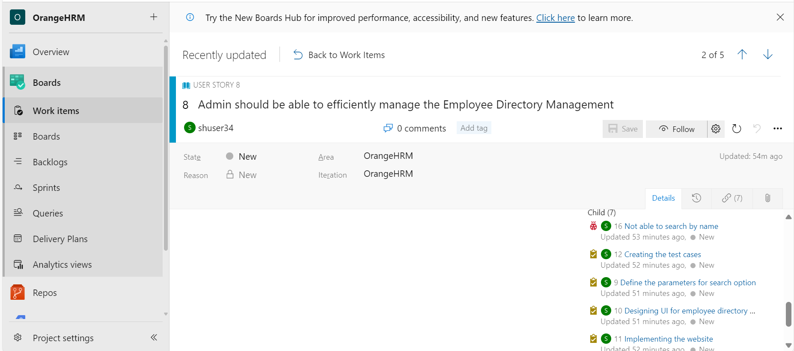

**User Story-3**

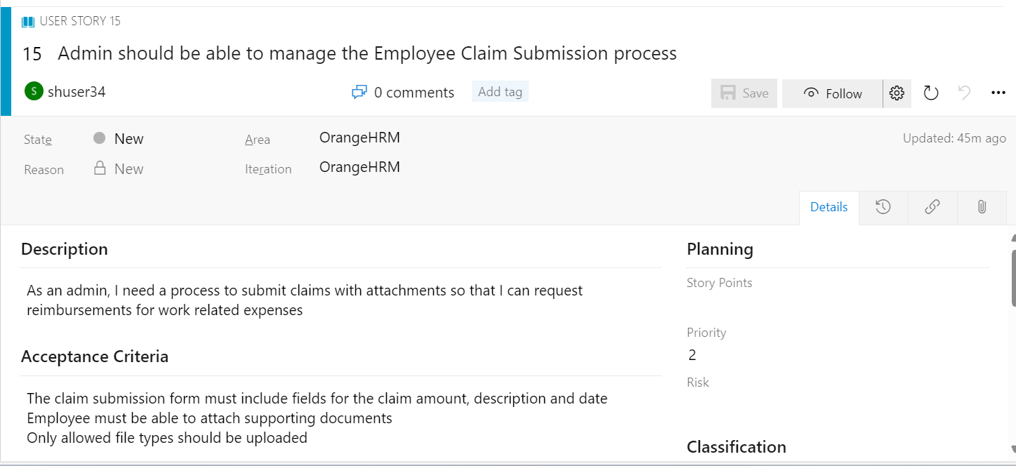

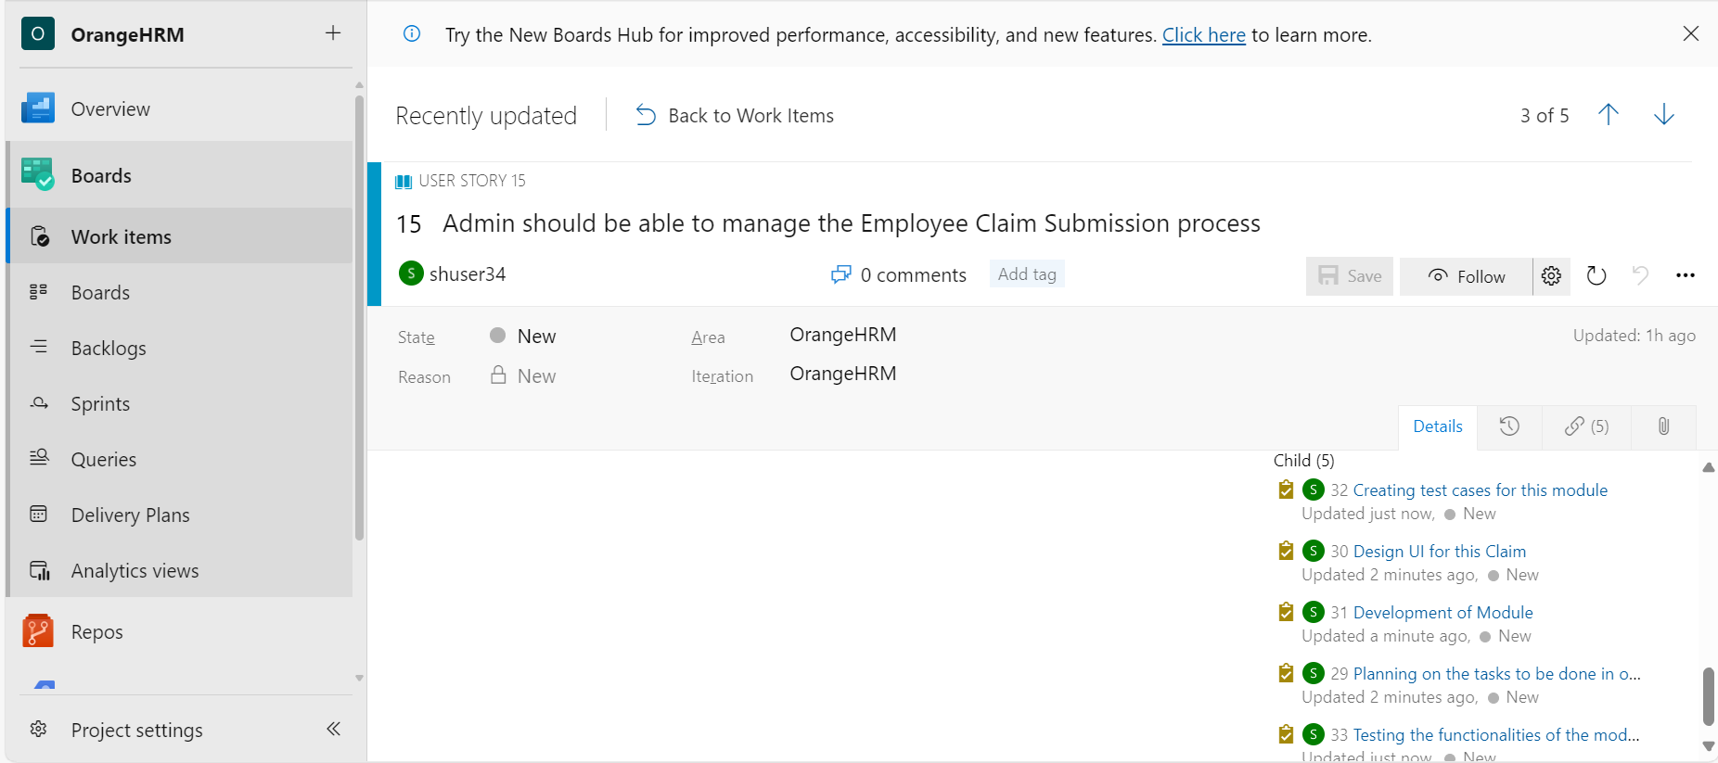

**User Story-4**

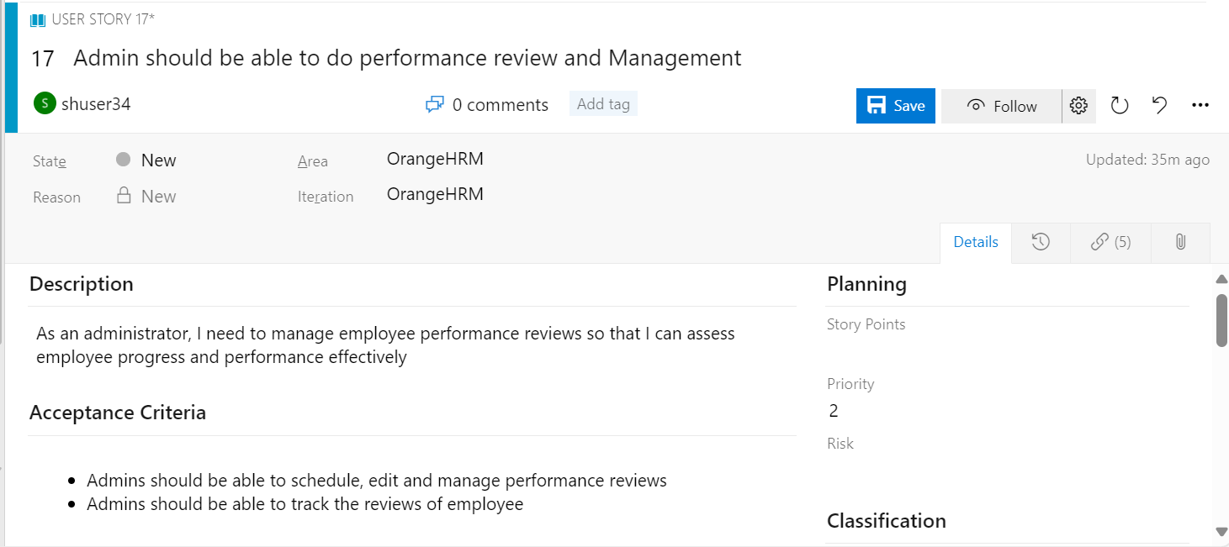

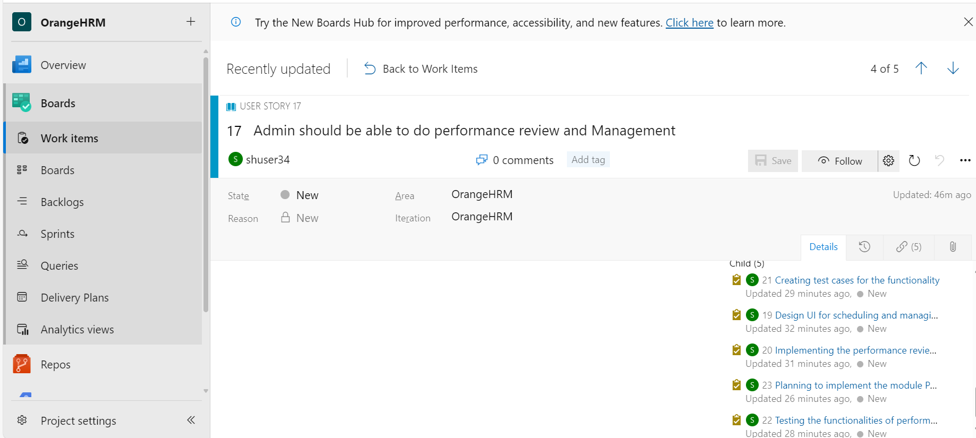

**User Story – 5**

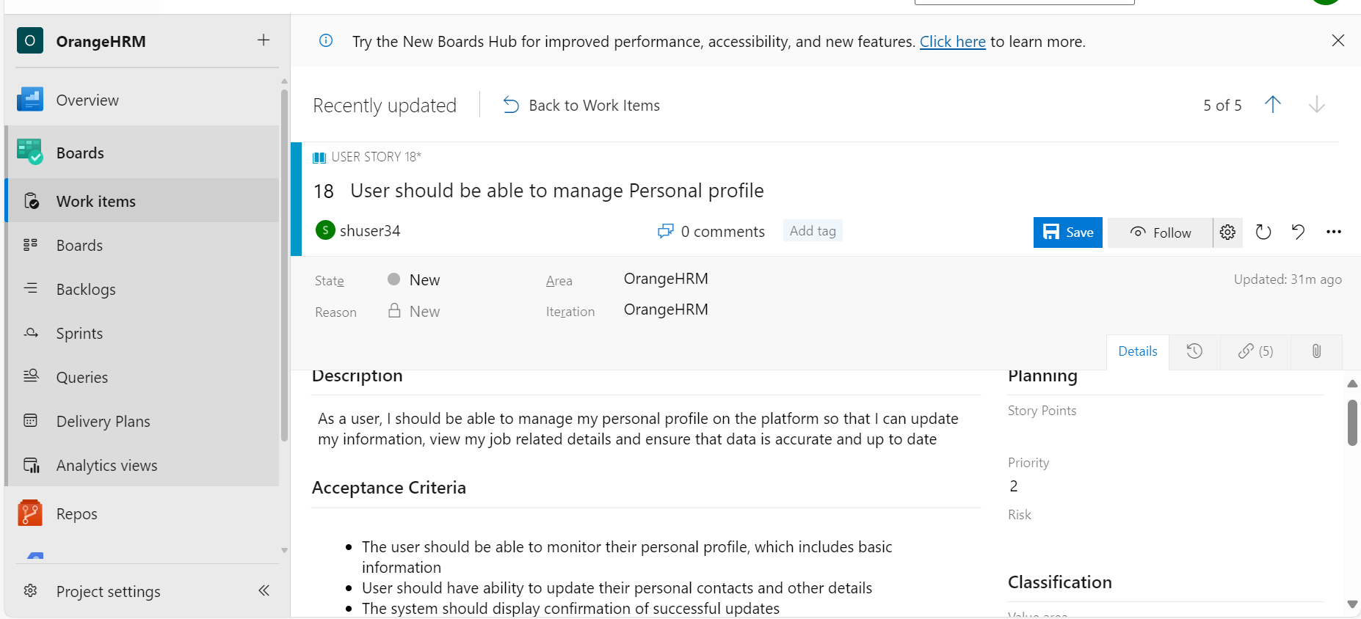

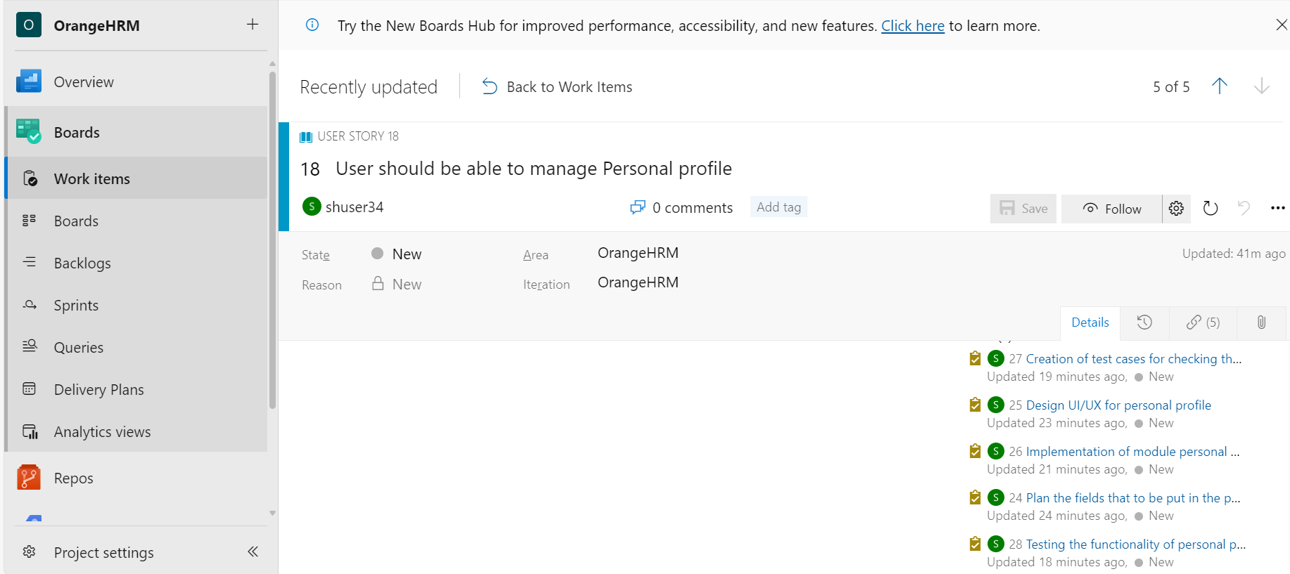

1. Create 25 test cases for the user stories created for the Sprint.

**Test Cases for User Story-1**

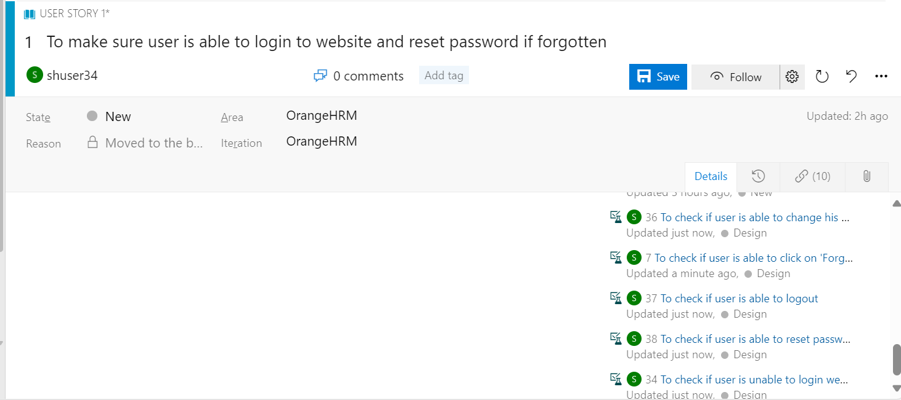

**Test Cases for User Story-2**

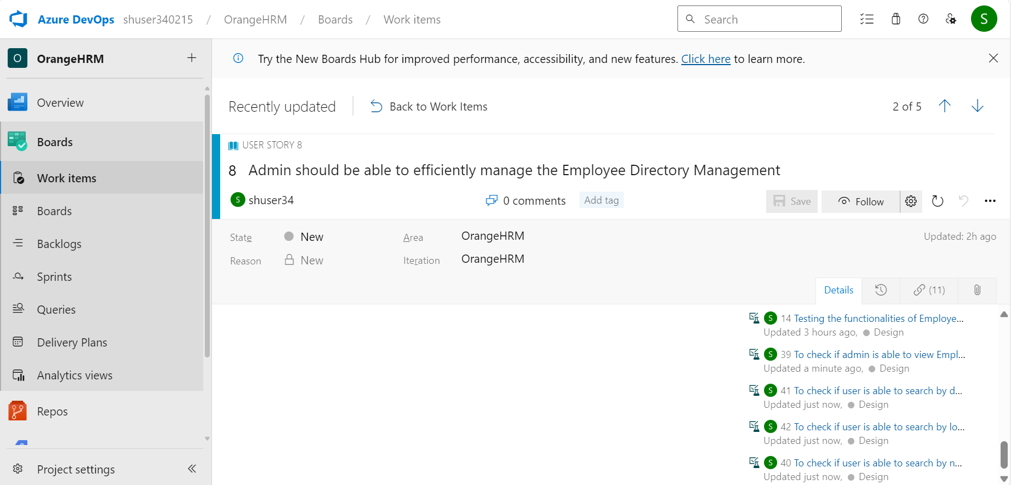

**Test Cases for User Story-3**

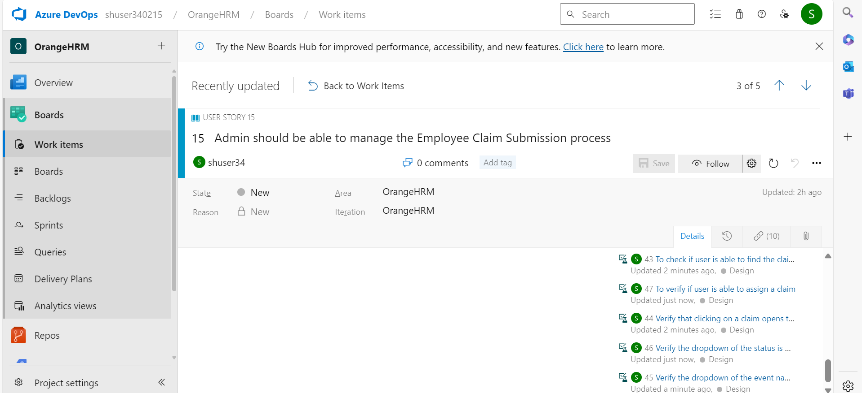

**Test Cases for User Story-4**

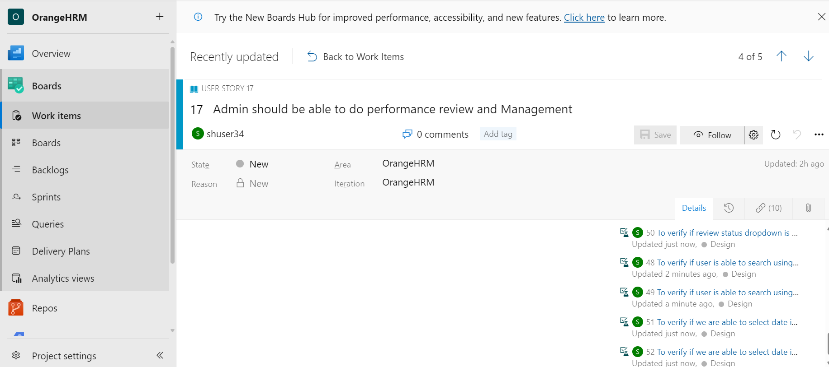

**Test Cases for User Story-5**

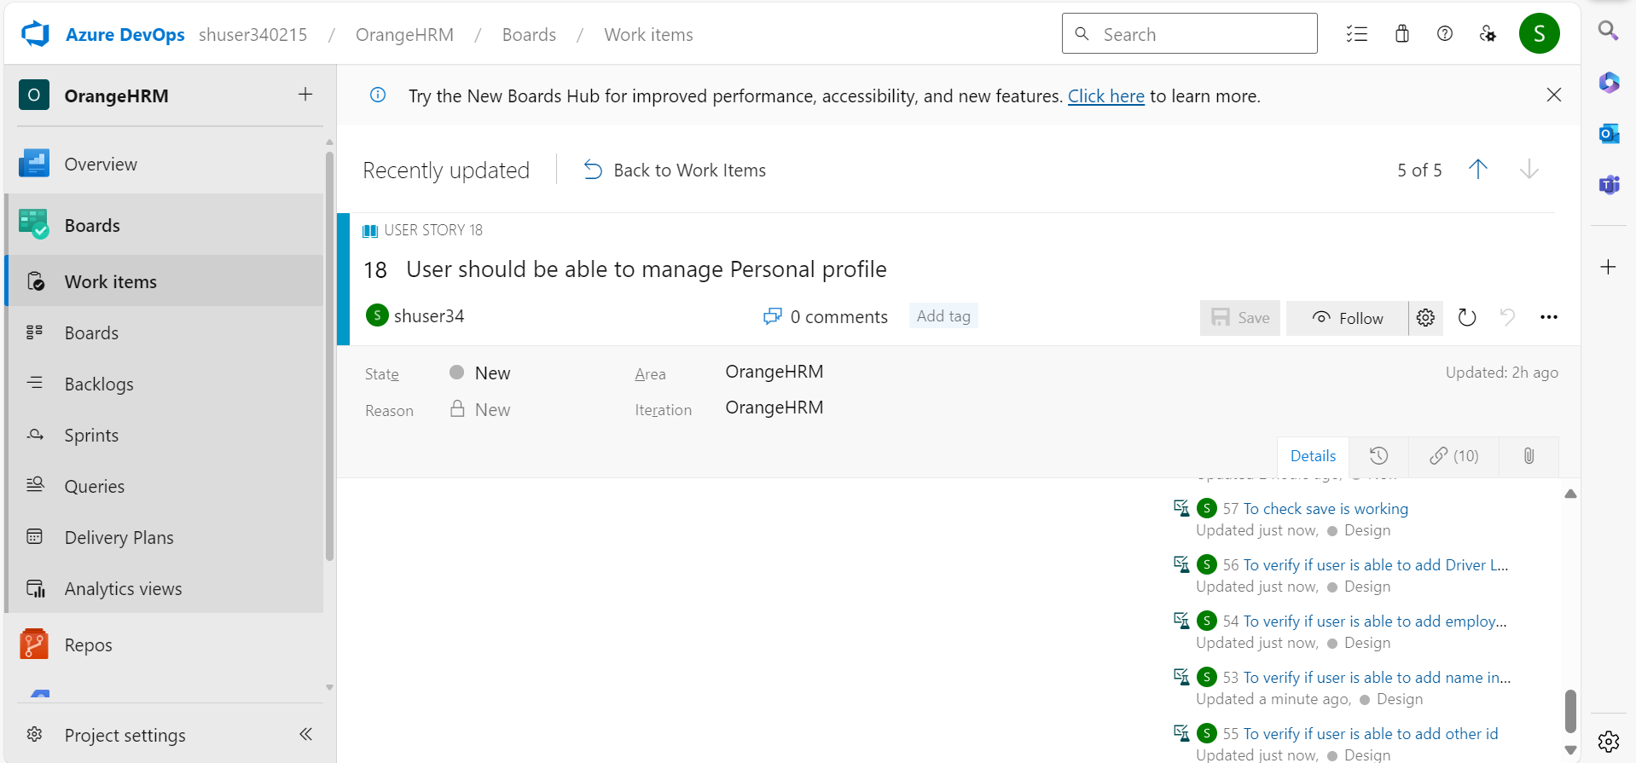

**All Test Cases Report**

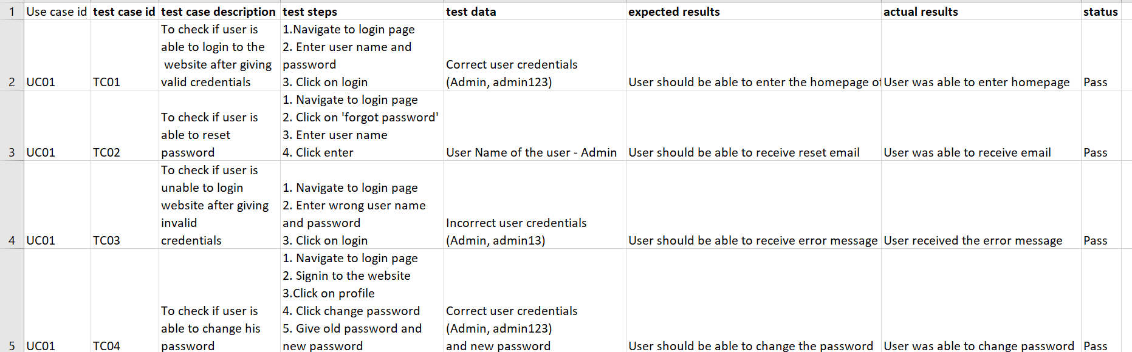

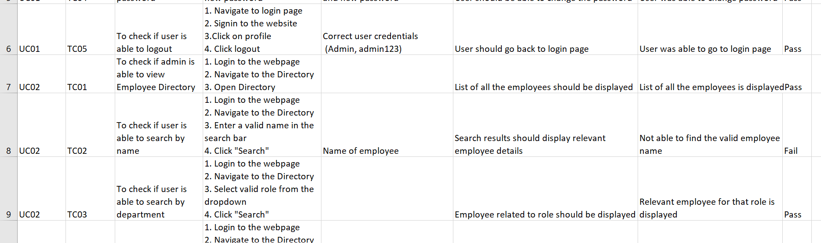

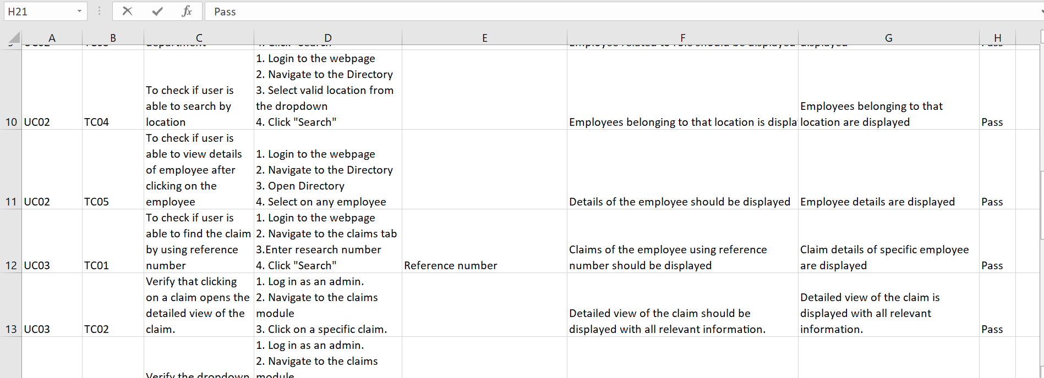

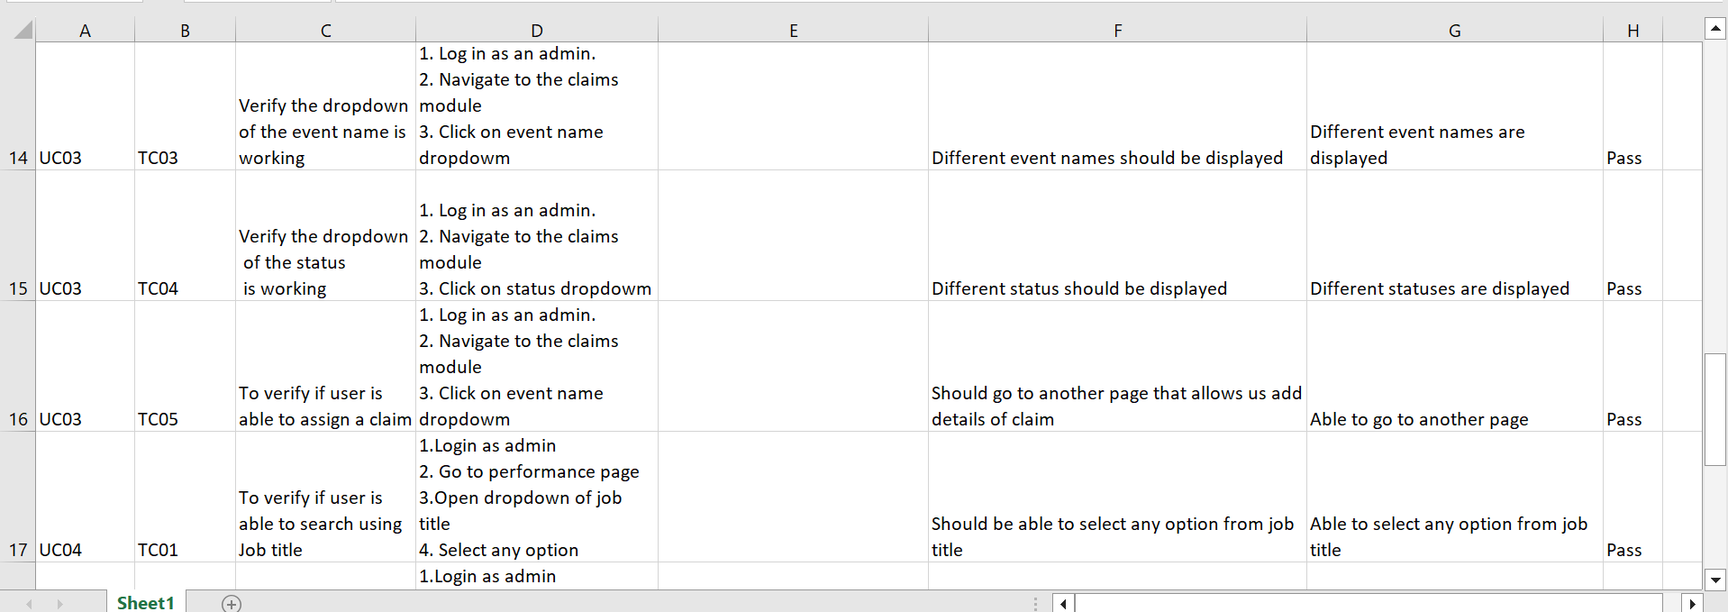

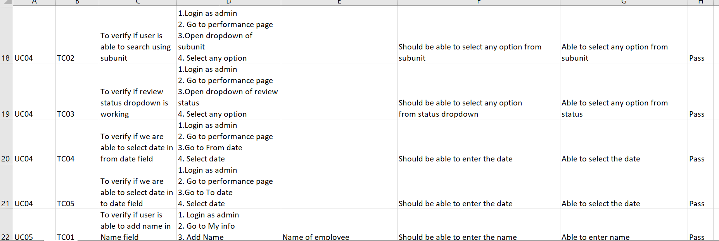

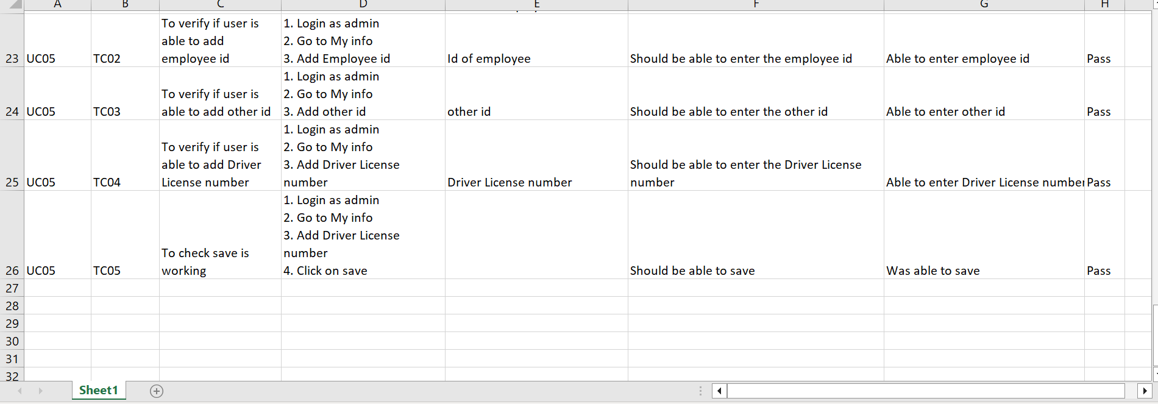

1. Define the tasks and sub tasks for each User Story.

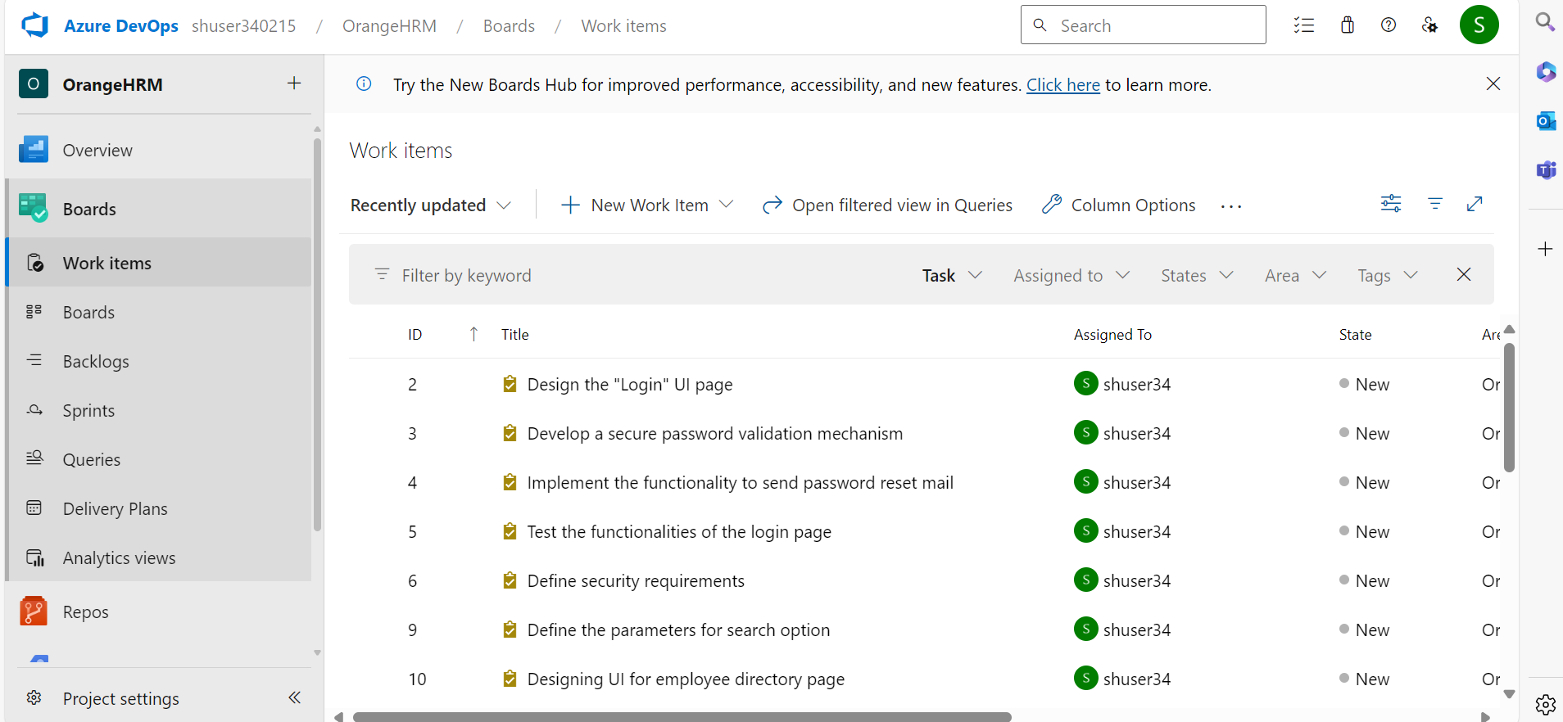

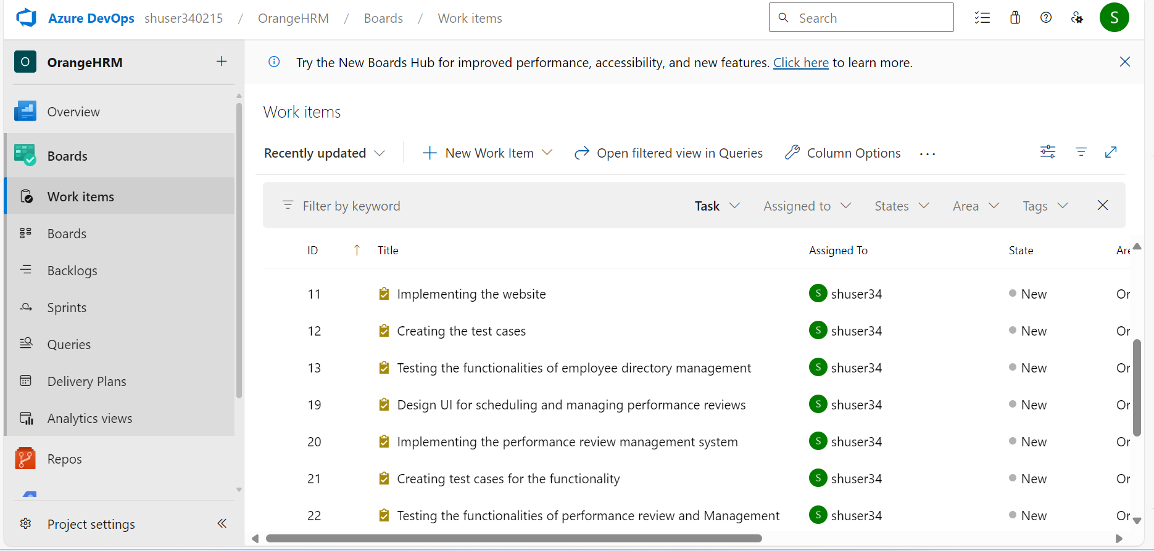

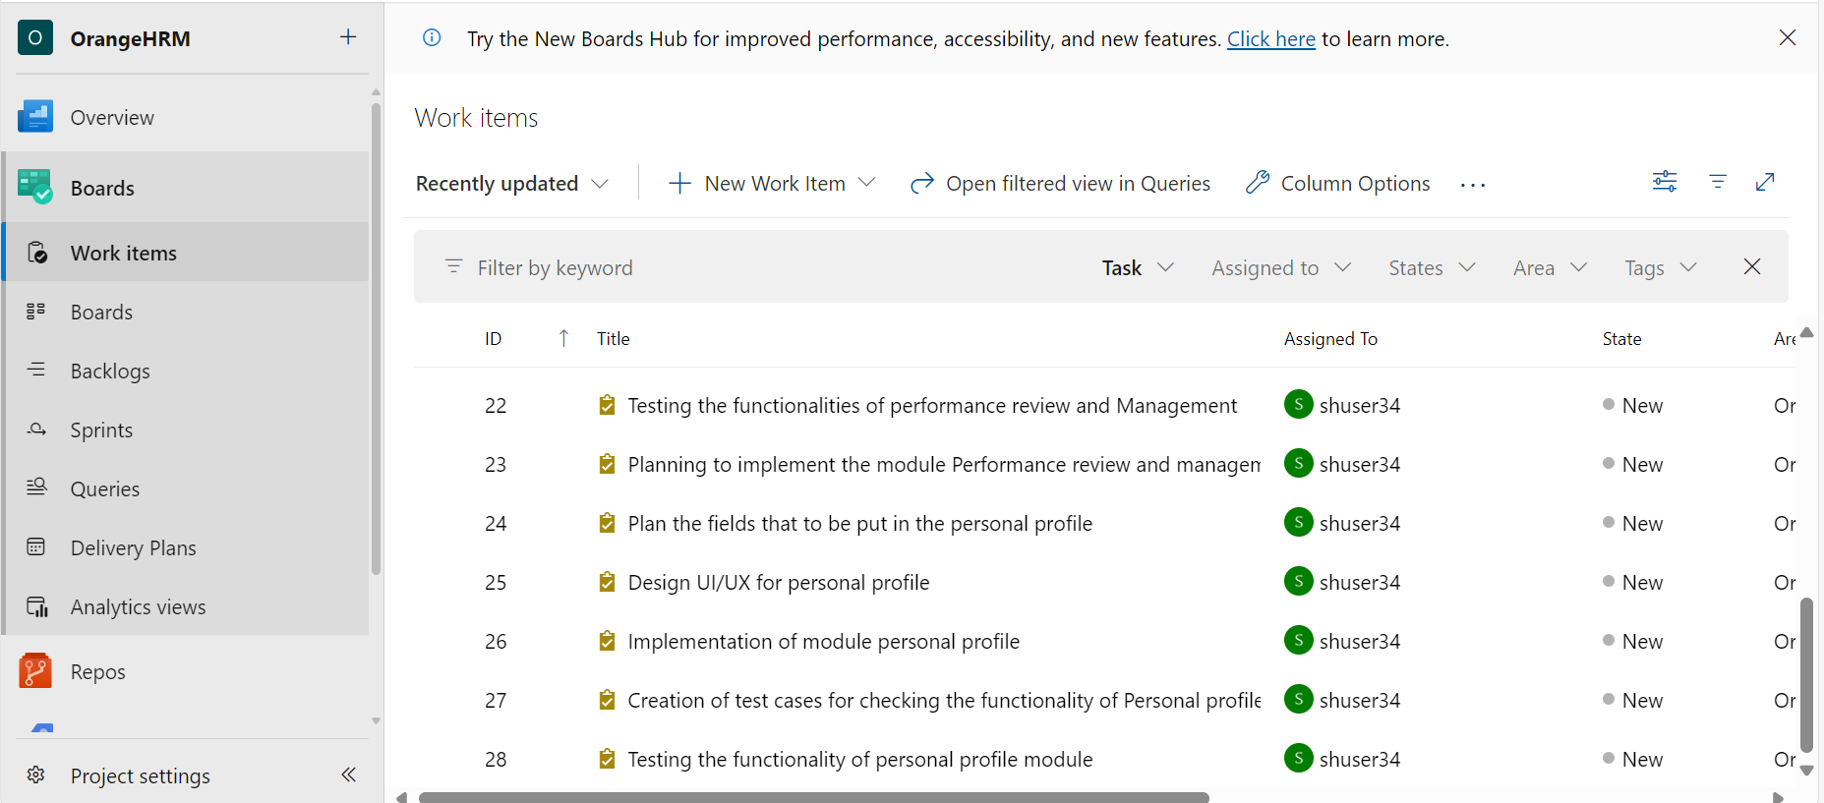

**Tasks for User Story-1**



**Tasks for User Story-2**



**Tasks for User Story-3**



**Tasks for User Story-4**



**Tasks for User Story- 5**



1. Execute all the test cases manually (functional testing).

**UC01-TC01**

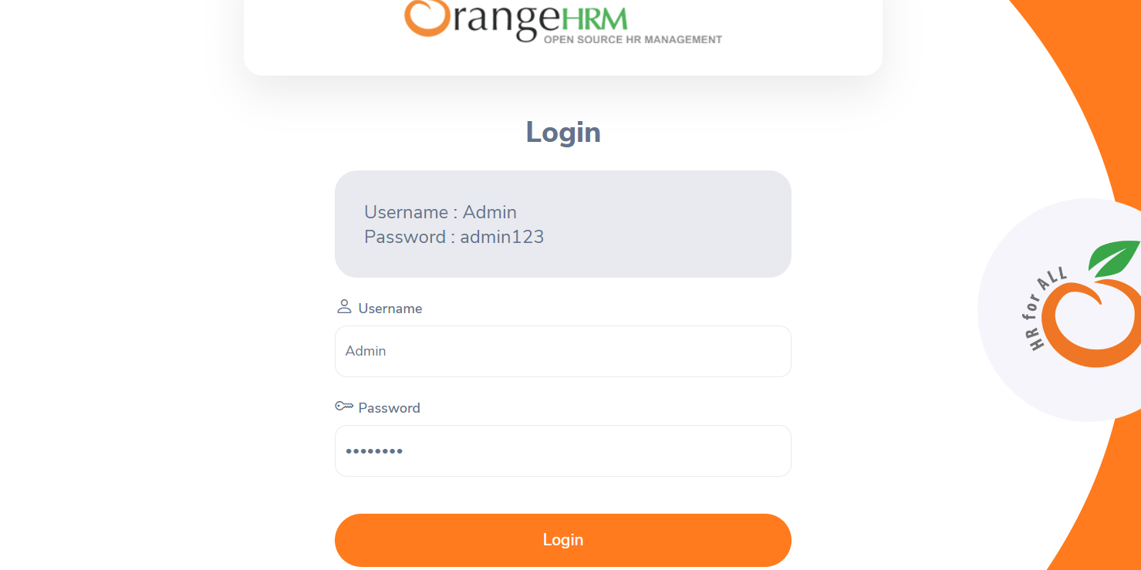

Able to login after giving correct credentials

**UC01-TC02**

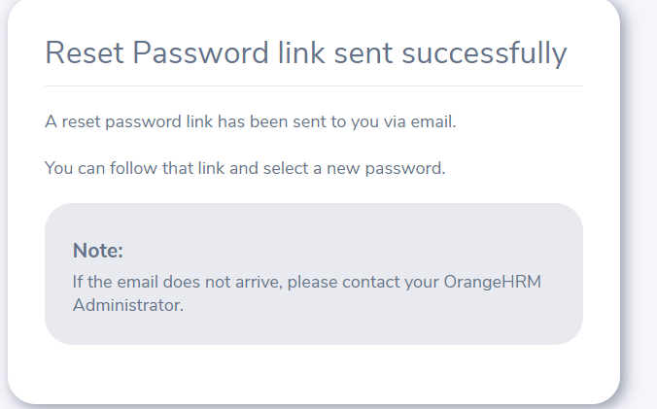

Able to reset password

**UC01-TC03**

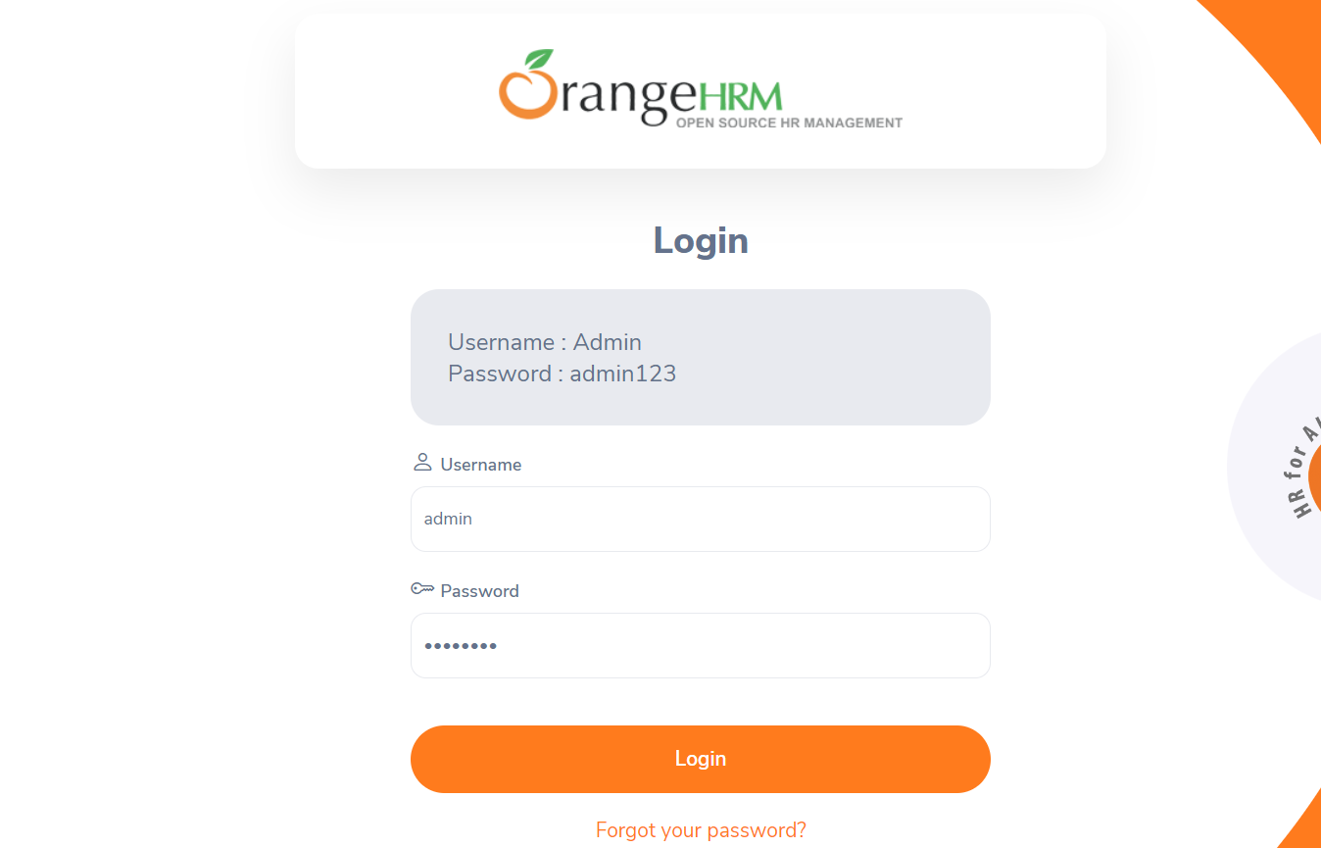

Even though, I gave incorrect credentials, it is being logged in

**UC01-TC04**

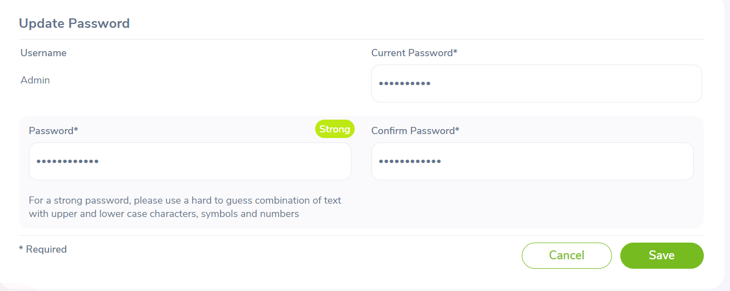

I was able to update password

**UC01-TC05**

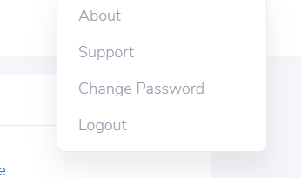

**UC02 – TC02**

**User story – 2 && Test Case-2**

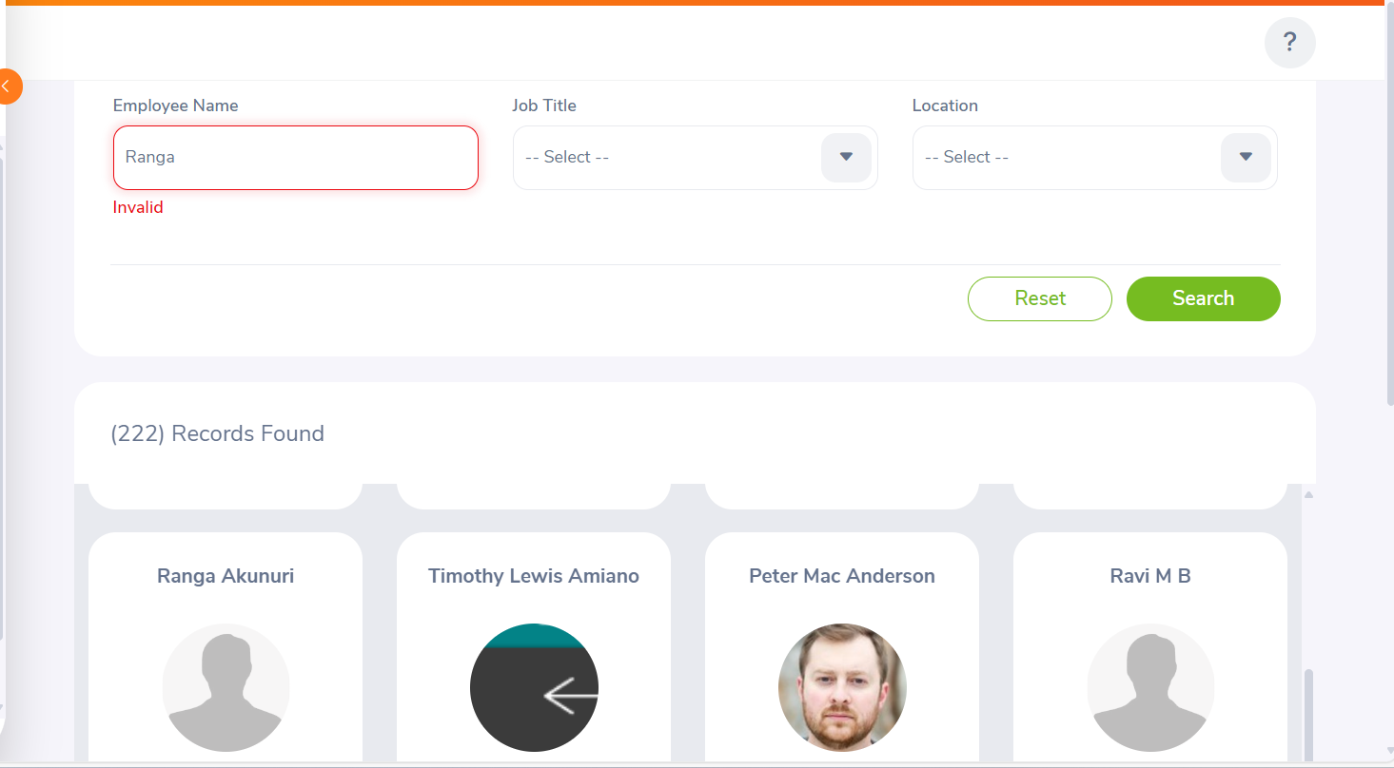

**Search option is not functioning properly**

1. Create a Defect Report for each failed or blocked test case.



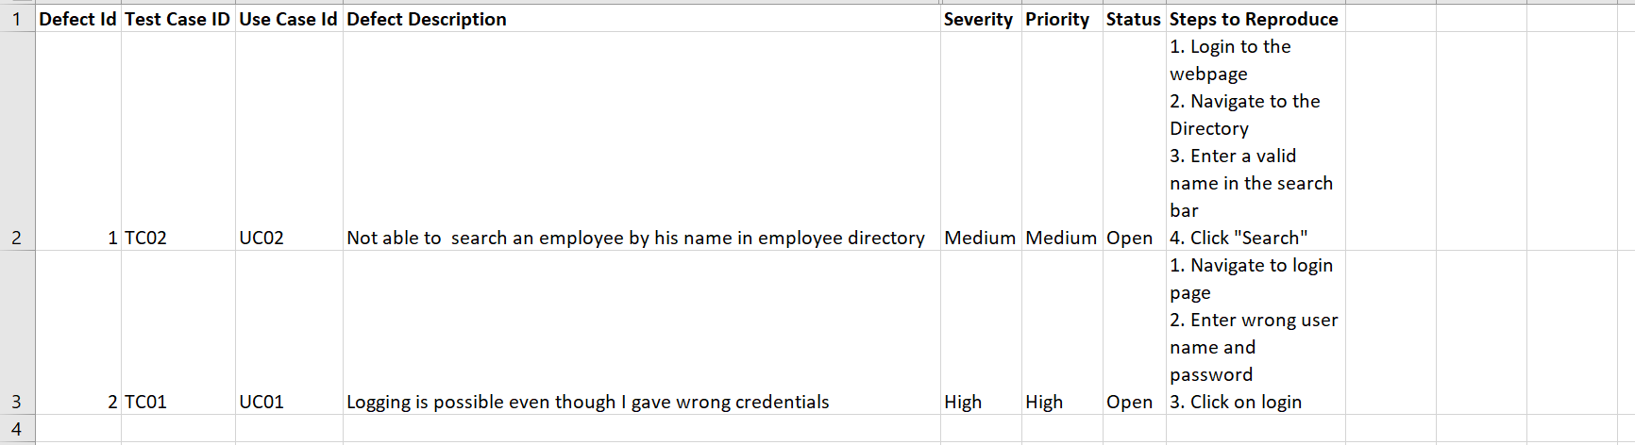

**Implementing the CI/CD Pipeline using GitHub Actions**

11. Create a new repository on your GitHub account

12. Clone the code base of the Java (any preferred language) project into your repository. The project’s codebase would be present in the VM.

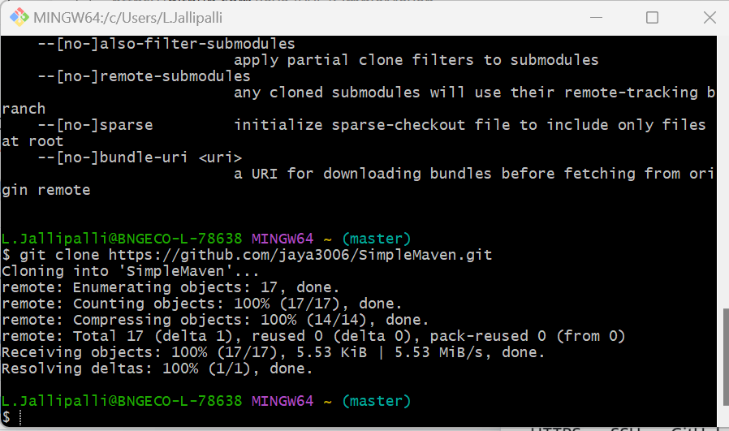

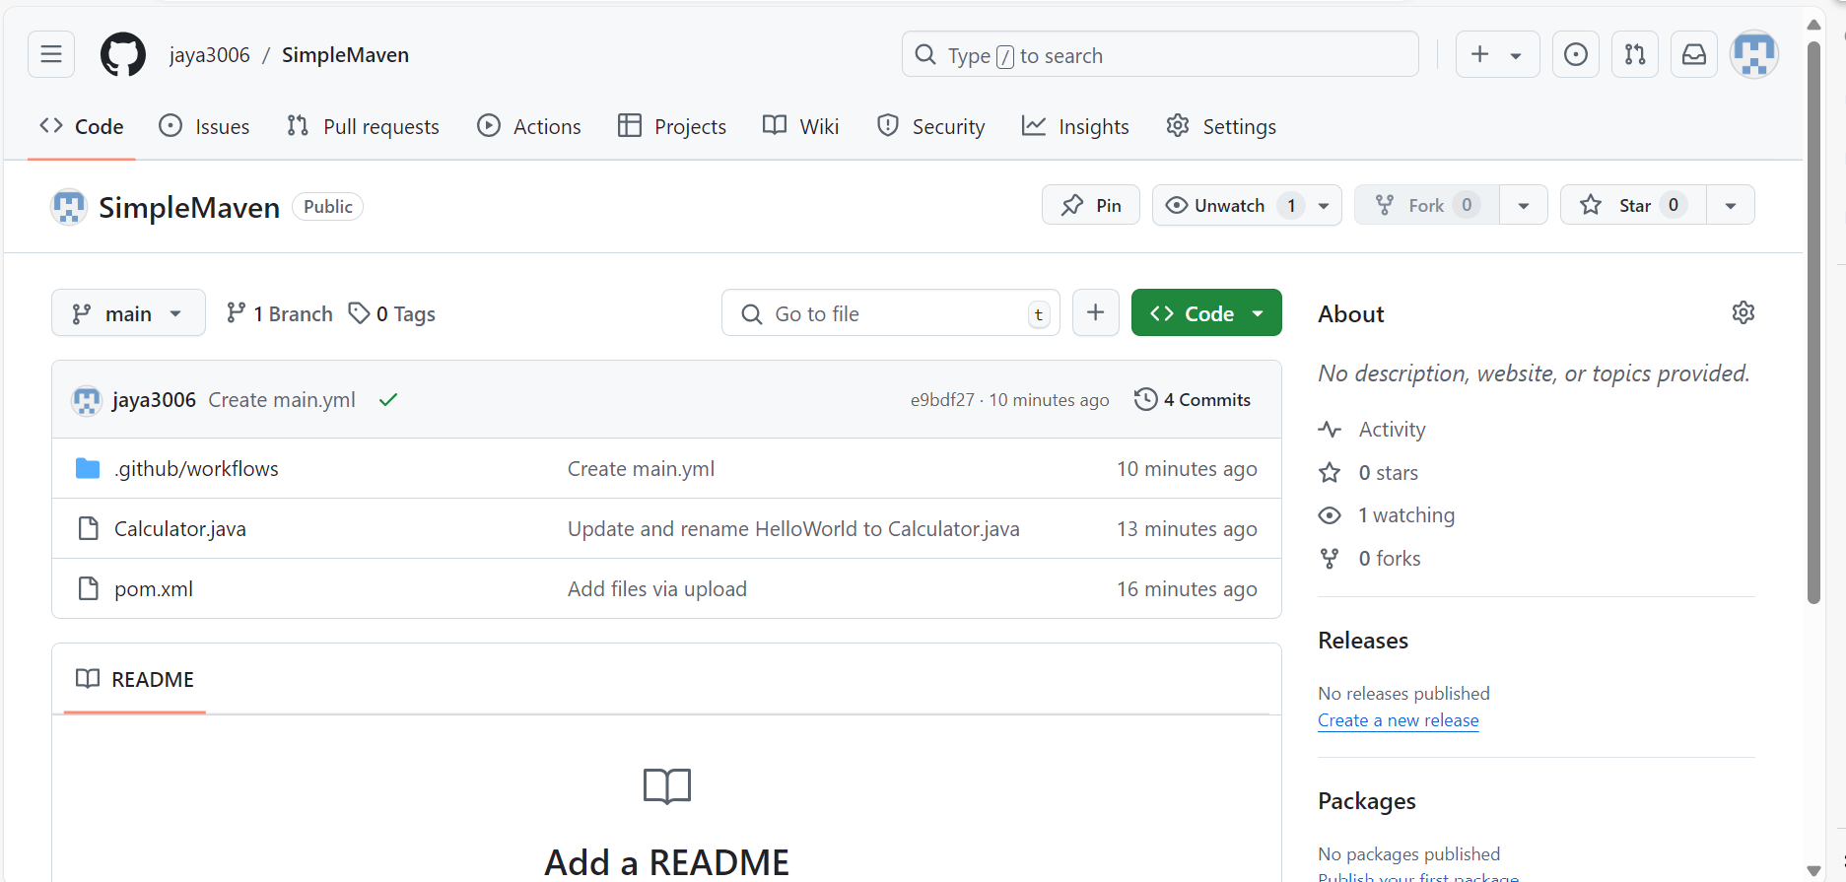

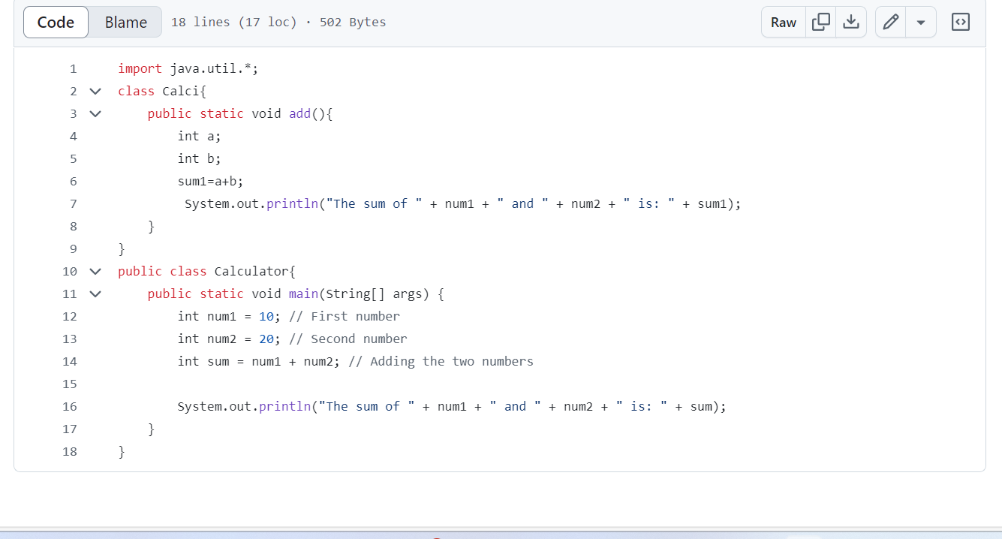

13. Create a New Workflow on GitHub Actions for the Java/Maven code.

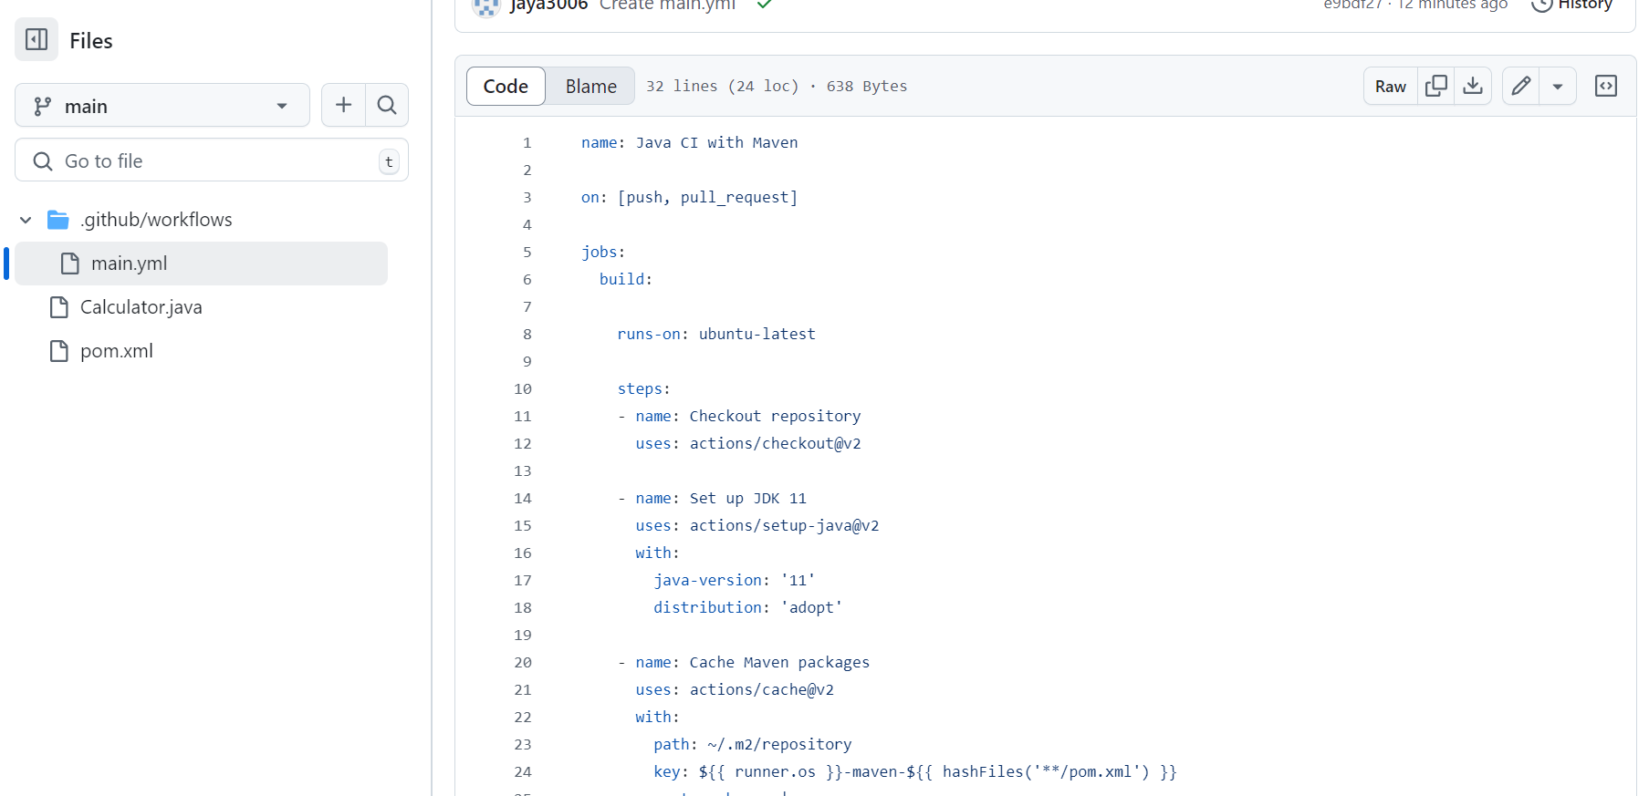

14. Monitor the build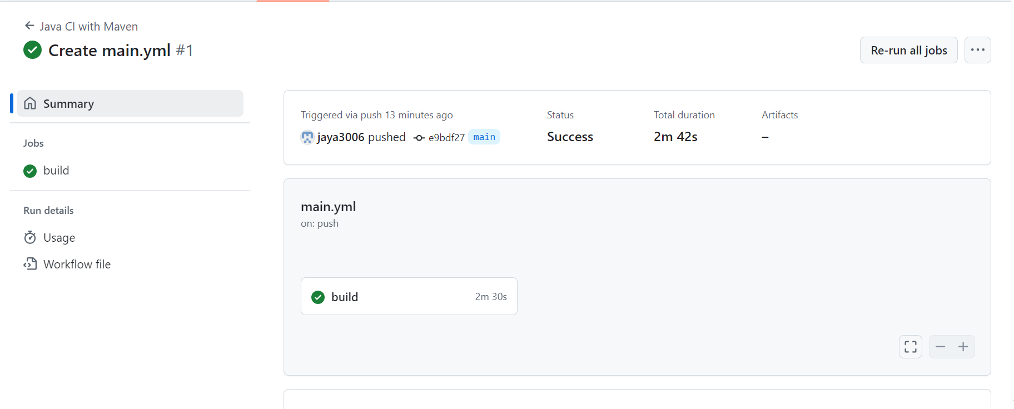

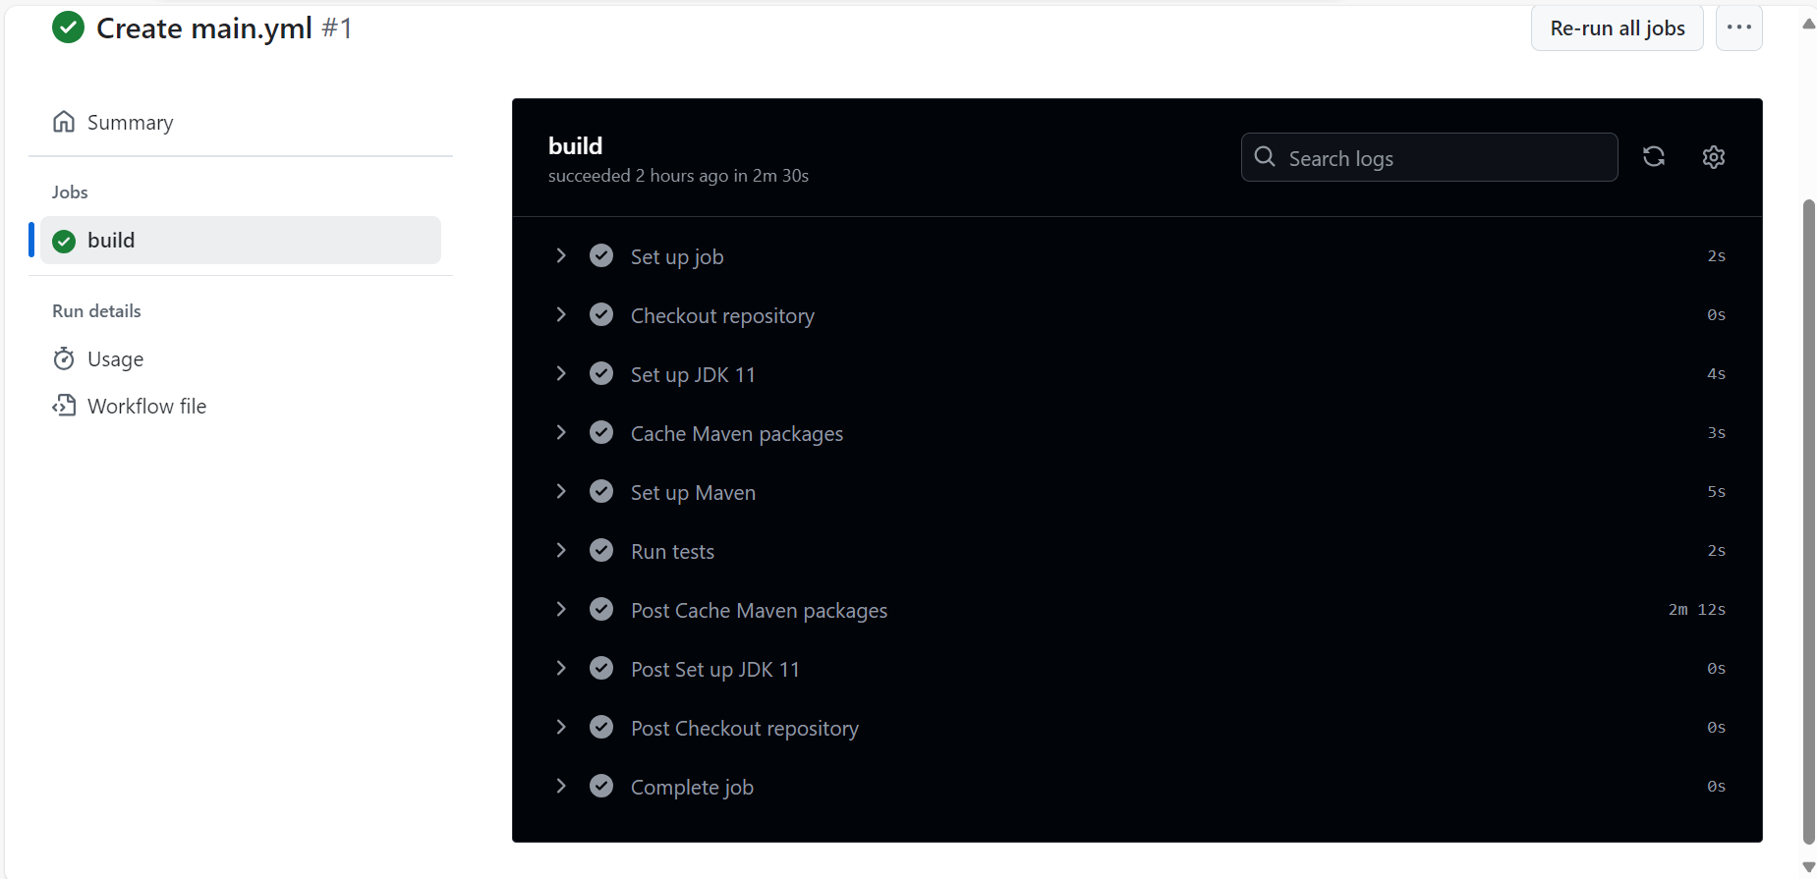

15. Modify the code in your repository to recheck the Workflow and the Build. For example, you could modify a Java class or update the pom.xml file.

Added an extra class Calci

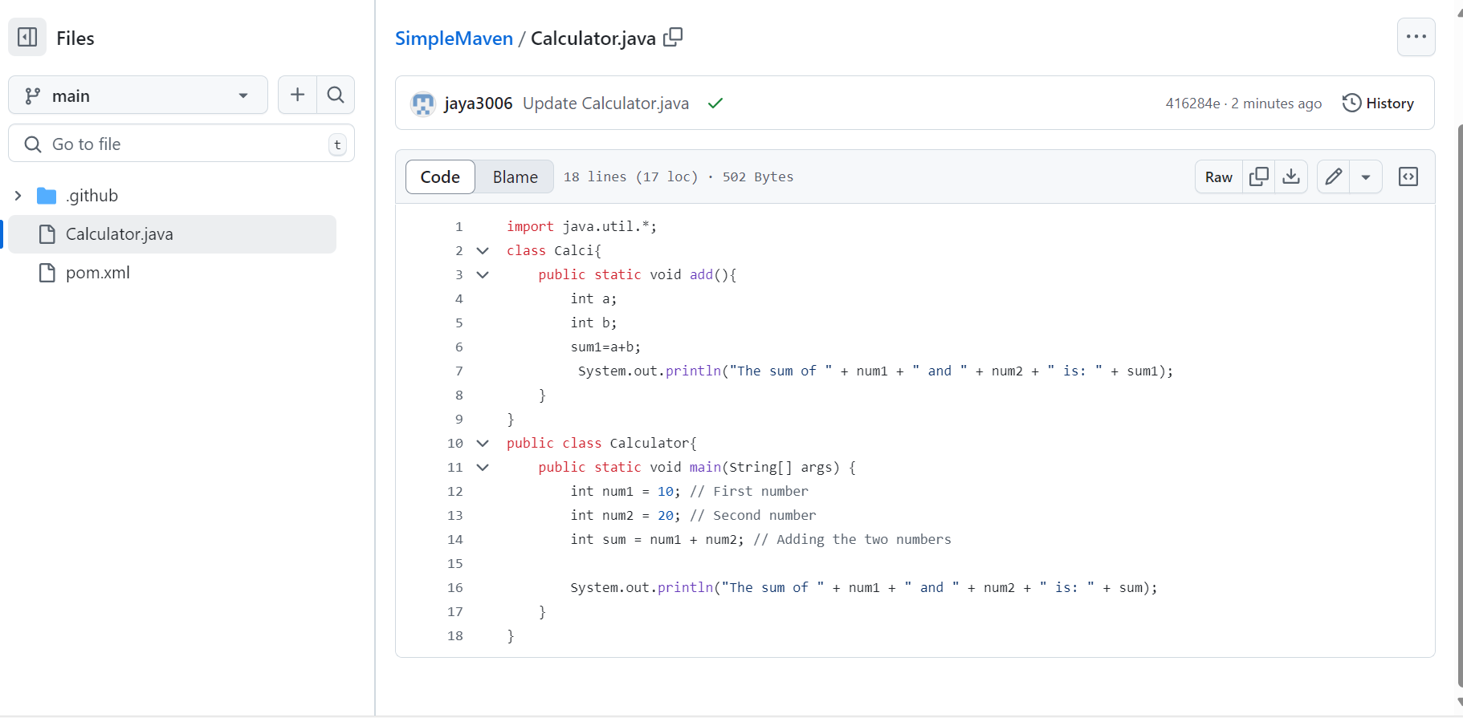

16. Commit it and monitor the build result

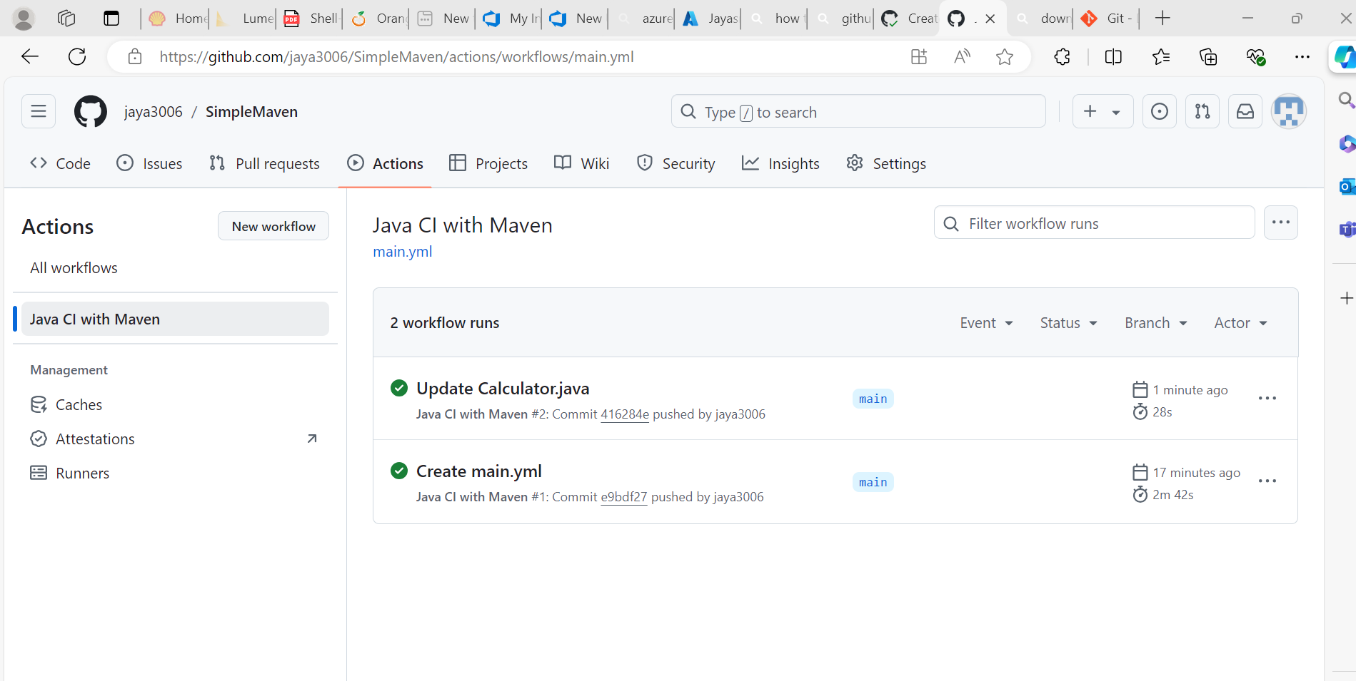

17. Update the screenshot of successful build and commit it in the repo

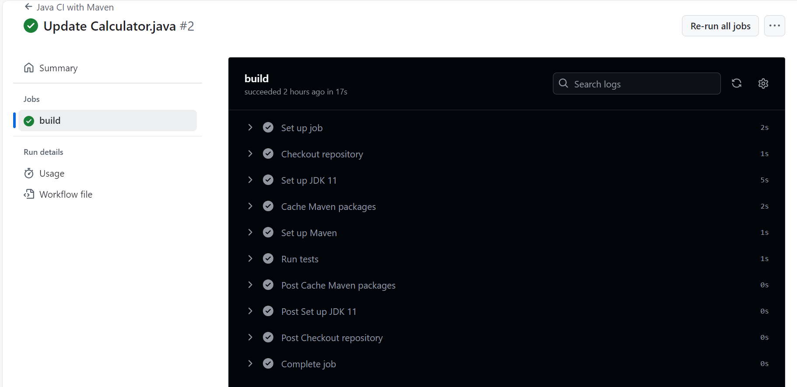

18. In your repository, add the created test cases report and defect report

**Github repository link:** <https://github.com/jaya3006/SimpleMaven.git>